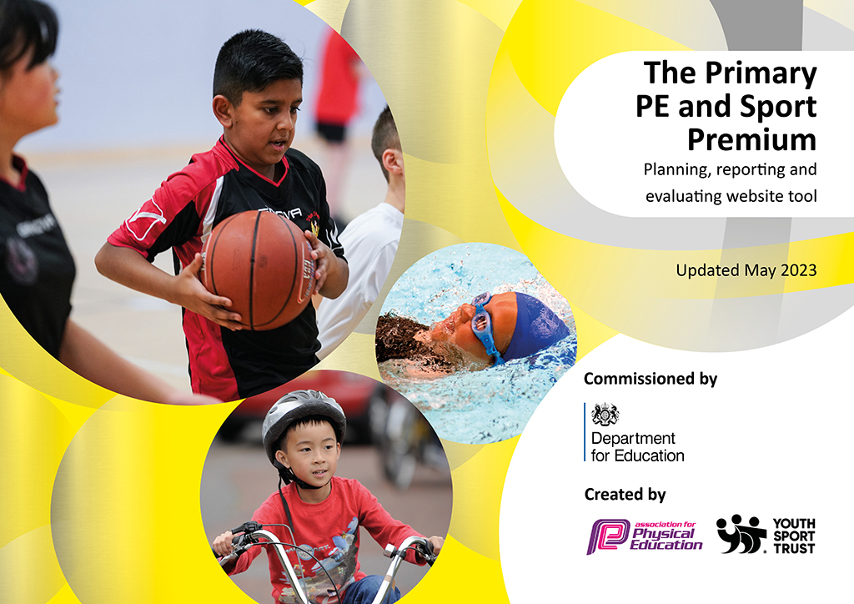
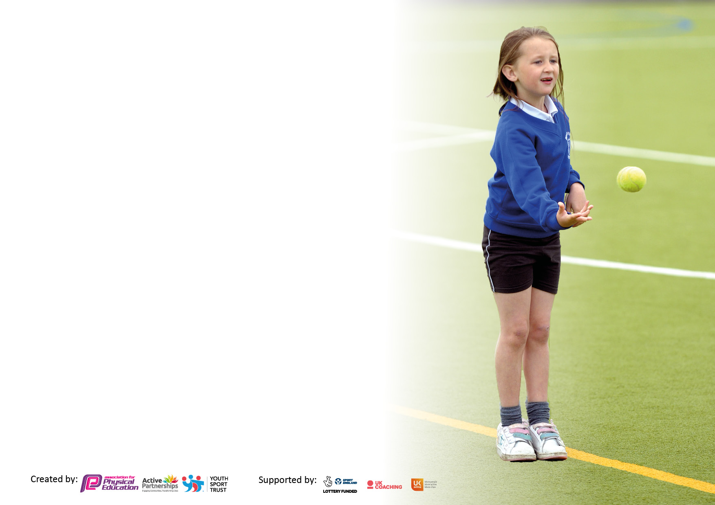

It is important that your grant is used effectively and based on school need. The Education Inspection Framework makes clear there will be a focus on ‘whether leaders and those responsible for governors all understand their respective roles and perform these in a way that enhances the effectiveness of the school’.

Under the Quality of Education Ofsted inspectors consider:
Intent - Curriculum design, coverage and appropriateness
Implementation - Curriculum delivery, Teaching (pedagogy) and Assessment
Impact - Attainment and progress

To assist schools with common transferable language this template has been developed to utilise the same three headings which should make your plans easily transferable between working documents.

Schools must use the funding to make additional and sustainable improvements to the quality of Physical Education, School Sport and Physical Activity (PESSPA) they offer. This means that you should use the Primary PE and sport premium to:

- Develop or add to the PESSPA activities that your school already offer
- Build capacity and capability within the school to ensure that improvements made now will benefit pupils joining the school in future years
- The Primary PE and sport premium should not be used to fund capital spend projects; the school’s budget should fund these.

Pleasevisitgov.ukfortherevisedDfEguidanceincludingthe5keyindicatorsacrosswhichschoolsshoulddemonstrate animprovement.Thisdocumentwillhelpyoutoreviewyourprovisionandtoreportyourspend.DfEencouragesschools to use this template as an effective way of meeting the reporting requirements of the Primary PE and Sport Premium.

We recommend you start by reflecting on the impact of current provision and reviewing the previous spend.

Schools are required to publish details of how they spend this funding, including any under-spend from 2021/2022, as well as on the impact it has on pupils’ PE and sport participation and attainment. All funding must be spent by 31st July 2023.

We recommend regularly updating the table and publishing it on your website throughout the year. This evidences your ongoing self-evaluation of how you are using the funding to secure maximum, sustainable impact. Final copy must be posted on your website by the end of the academic year and no later than the 31st July 2023. To see an example of how to complete the table please click HERE.

Details with regard to funding
Please complete the table below.

Total amount carried over from 2021/22 | £0
Total amount allocated for 2021/22 | £16.800
How much (if any) do you intend to carry over from this total fund into 2022/23? | £0
Total amount allocated for 2022/23 | £17, 570
Total amount of funding for 2023/23. To be spent and reported on by 31st July 2023. | £ £17, 570
Swimming Data
Please report on your Swimming Data below.

Meeting national curriculum requirements for swimming and water safety.  N.B. Complete this section to your best ability. For example you might have practised safe self-rescue techniques on dry land which you can then transfer to the pool when school swimming restarts.  Due to exceptional circumstances priority should be given to ensuring that pupils can perform safe self rescue even if they do not fully meet the first two requirements of the NC programme of study | N/A
What percentage of your current Year 6 cohort swim competently, confidently and proficiently over a distance of at least 25 metres?  N.B. Even though your pupils may swim in another year please report on their attainment on leaving primary school at the end of the summer term 2022.  Please see note above | N/A
What percentage of your current Year 6 cohort use a range of strokes effectively [for example, front crawl, backstroke and breaststroke]?  Please see note above | N/A
What percentage of your current Year 6 cohort perform safe self-rescue in different water-based situations? | N/A
Schools can choose to use the Primary PE and sport premium to provide additional provision for swimming but this must be for activity over and above the national curriculum requirements. Have you used it in this way? | N/A

Action Plan and Budget Tracking
Capture your intended annual spend against the 5 key indicators. Clarify the success criteria and evidence of impact that you intend to measure to evaluate for pupils today and for the future.

Academic Year: 2022/23 | Total fund allocated: £17, 570 | Date Updated: July 2023
Key indicator 1: The engagement of all pupils in regular physical activity – Chief Medical Officers guidelines recommend that primary school pupils undertake at least 30 minutes of physical activity a day in school |  |  |  | Percentage of total allocation:
 |  |  |  | 82% £14, 430
Intent | Implementation |  | Impact
Your school focus should be clear what you want the pupils to know and be able to do and about  what they need to learn and to  consolidate through practice: | Make sure your actions to achieve are linked to your intentions: | Funding allocated: | Evidence of impact: what do pupils now know and what can they now do? What has changed?: | Sustainability and suggested next steps:
-All children to have opportunities for high quality physical activity for at least 30 minutes per day. | - New playground equipment installed-access to this daily.  - Daily morning wake and shake for 10 minutes  -New sports equipment ordered for playground (consumables) | £4930 contributed to towards the full cost.  £9500 | -Behaviour and engagement has improved during lunch and playtime.  -fewer accidents on the playground at lunch and playtime.  -Pupil voice shows children are enjoying opportunities for active play. | - To increase loose parts play during lunchtime -sourcing resources.  -Equipment to be well maintained.  -Sports coach to lead active play three times a week at lunch, working alongside the midday supervisors to improve interactions and engagement levels.
Key indicator 2: The profile of PESSPA being raised across the school as a tool for whole school improvement |  |  |  | Percentage of total allocation:
 |  |  |  | 3% £540
Intent | Implementation |  | Impact
Your school focus should be clear what you want the pupils to know and be able to do and about  what they need to learn and to  consolidate through practice: | Make sure your actions to achieve are linked to your intentions: | Funding allocated: | Evidence of impact: what do pupils now know and what can they now do? What has changed?: | Sustainability and suggested next steps:
-To celebrate physical activity and sports across the school and raise the profile of PE.  -To raise the awareness of the link between physical activity and health across the school. | -Sports Day- annual sports day allowing children to all participate in competition and celebrate achievement.  Assemblies based on world sports events e.g. Wimbledon  -Sports Ambassadors introduced and support the PE lead to monitor and champion sport in school.  -Jigsaw PSHE focus on healthy me | £ 540 | - Pupil voice shows children know the importance of physical activity in order to stay healthy.  - Sports ambassadors are engaged in monitoring and celebrating PE across the school.  - Children are aware of national and international sports events. | - Athlete visits arranged for the Autumn term.  - Specialist sports days for national and international events.  - Calendar of events shared with parents  - Involve local community- reach out to local teams and networks to support and celebrate sport in school.

Key indicator 3: Increased confidence, knowledge and skills of all staff in teaching PE and sport |  |  |  | Percentage of total allocation:
 |  |  |  | 15% £2,600
Intent | Implementation |  | Impact
Your school focus should be clear | Make sure your actions to | Funding | Evidence of impact: what do | Sustainability and suggested
what you want the pupils to know | achieve are linked to your | allocated: | pupils now know and what | next steps:
and be able to do and about | intentions: |  | can they now do? What has
what they need to learn and to |  |  | changed?:
consolidate through practice:
Teachers are knowledgeable about the PE curriculum and how it is progressive and sequential. Staff are confident to teach PE. | Get set for PE bought to provide all planning- high quality planning and teaching of PE for all year groups.  Access to CPD via get set for PE for all teachers.  Specialist Dance teacher employed to model, teach and coach teachers, including ECT. | £2,600 | Monitoring shows that PE lessons are well planned and delivered.  Pupil voice shows that children enjoy PE lessons and can talk about their developing skills and knowledge.  Staff voice shows they are confident in teaching PE. | -Premier delivering CPD to all teachers over the year.  -Specialist dance teacher employed for Autumn term, to provide CPD for Foundation teachers.  Subject monitoring by PE lead identifies priorities for CPD for the next academic year.
Key indicator 4: Broader experience of a range of sports and activities offered to all pupils |  |  |  | Percentage of total allocation:
 |  |  |  | 0
Intent | Implementation |  | Impact
Your school focus should be clear | Make sure your actions to | Funding | Evidence of impact: what do | Sustainability and suggested
what you want the pupils to know | achieve are linked to your | allocated: | pupils now know and what | next steps:
and be able to do and about | intentions: |  | can they now do? What has
what they need to learn and to |  |  | changed?:
consolidate through practice:
The whole school offer is broad and all children are given a range of opportunities to experience different sports. | -After school club offer is broad and has included but not limited to;  Yoga  MK dons football  Girls football  Multisports  Dance | £0 | High take up of clubs-all are fully booked.  Pupil and parent voice show that children enjoy the clubs on offer. | -New range of clubs planned for September 2023-to be facilitated by Premier. This is to link termly to world sports events. E.g ruby club while the rugby world cup is on and will be partially funded by Sports premium.

Key indicator 5: Increased participation in competitive sport |  |  |  | Percentage of total allocation:
 |  |  |  | %
Intent | Implementation |  | Impact
Your school focus should be clear | Make sure your actions to | Funding | Evidence of impact: what do | Sustainability and suggested
what you want the pupils to know | achieve are linked to your | allocated: | pupils now know and what | next steps:
and be able to do and about | intentions: |  | can they now do? What has
what they need to learn and to |  |  | changed?:
consolidate through practice:
Children will have a variety of opportunities to participate in competitive sport. | -Sports Day- June 2023  -Competition with self in KS1, evidenced in planning. |  | Feedback from pupils and staff is that sports day was well organized and received. | -Support a Trust plan to increase the opportunities for competitive sport within infant schools, moving forwards.

Signed off by
Head Teacher:
Date: | 20/07/2023
Subject Leader: | Siobhan Hennessy
Date: | 20.7.23
Governor: | Jess Elford
Date: | 20.7.23

